# Importing Libraries

# Used for Data Manipulation and Analysis
import pandas as pd
import numpy as np
import io

# Used for Data Visualization
import seaborn as sns
import matplotlib.pyplot as plt
plt.style.use('seaborn-bright')

# Used for NLP
import nltk
import re
from nltk.corpus import stopwords
from nltk.stem.porter import PorterStemmer
from nltk.stem import WordNetLemmatizer
from wordcloud import WordCloud
from sklearn.feature_extraction.text import CountVectorizer
from sklearn.feature_extraction.text import TfidfVectorizer
from tensorflow.keras.preprocessing.sequence import pad_sequences
from sklearn.linear_model import LogisticRegression
from sklearn.metrics import classification_report,accuracy_score
from sklearn.naive_bayes import MultinomialNB
from tensorflow.keras.layers import LSTM,Bidirectional,GRU,MaxPooling1D,Conv1D
from tensorflow.keras.layers import Dense
from tensorflow.keras.layers import Embedding,Dropout
from tensorflow.keras.models import Sequential

# Reading data from csv
url1 = 'https://raw.githubusercontent.com/bhartio123/omprojectfile/main/train.csv'
url2 = 'https://raw.githubusercontent.com/bhartio123/omprojectfile/main/test.csv'
train = pd.read_csv(url1)
test = pd.read_csv(url2)
train.head()

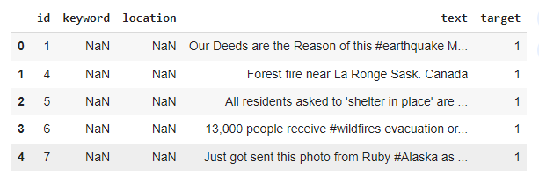

# Reading data from csv
test.head()

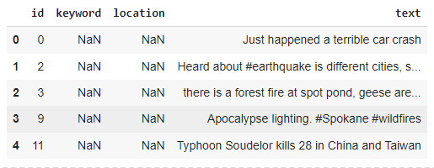

Let's explore the columns in the dataset id : A unique identifier for each tweet. keyword : A particular keyword from the tweet (may be blank). location: The location the tweet was sent from (may be blank). text : The text of the tweet. target : This denotes whether a tweet is about a real disaster (1) or not (0).
# Displaying rows and columns in dataset

print("There are {} rows and {} columns in training data".format(train.shape[0],train.shape[1]))
print("There are {} rows and {} columns in testing data".format(test.shape[0],test.shape[1]))

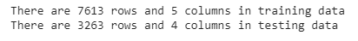
# explore the Target Variable
# Visualizing the target classes
plt.figure(figsize=(8,5))
plt.title("Count of Target Classes")
sns.countplot(y=train["target"],linewidth=3,
edgecolor='red', color='green')

plt.show()

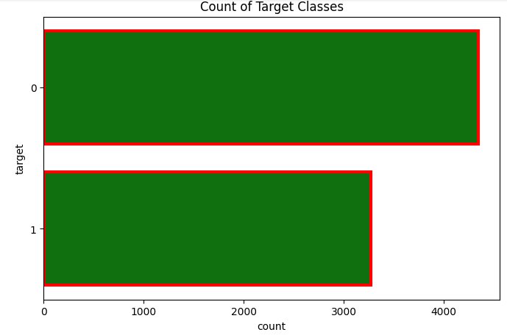
Analysing total number of characters in text.
fig,(ax1,ax2) = plt.subplots(1,2,figsize=(10,5))
char_len_dis = train[train['target']==1]['text'].str.len()
ax1.hist(char_len_dis,color='green',edgecolor='yellow', linewidth=1.2)
ax1.set_title('Disaster Tweets')
char_len_ndis = train[train['target']==0]['text'].str.len()
ax2.hist(char_len_ndis,color='blue',edgecolor='red', linewidth=2)
ax2.set_title('Non-Disaster Tweets')
plt.suptitle("Length of Characters in text")
plt.tight_layout()
plt.show()

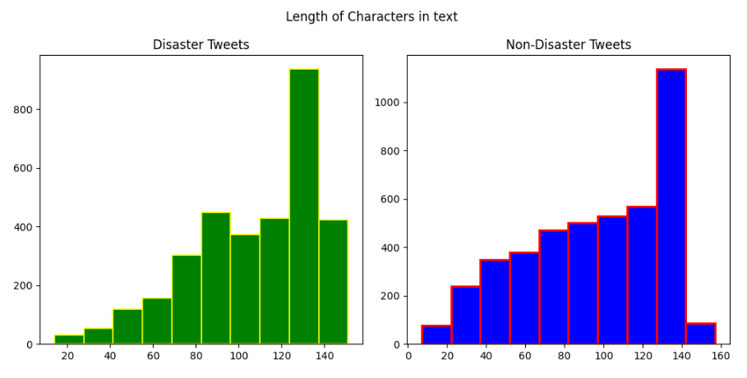
Analysing number of words in text.

fig,(ax1,ax2) = plt.subplots(1,2,figsize=(10,5))
char_len_dis = train[train['target']==1]['text'].str.split().map(lambda x: len(x))
ax1.hist(char_len_dis,color='yellow',edgecolor='black', linewidth=1.2)
ax1.set_title('Disaster Tweets')
char_len_ndis = train[train['target']==0]['text'].str.split().map(lambda x: len(x))
ax2.hist(char_len_ndis,color='pink',edgecolor='black', linewidth=1.2)
ax2.set_title('Non-Disaster Tweets')
plt.suptitle("Length of words in text")
plt.tight_layout()
plt.show()

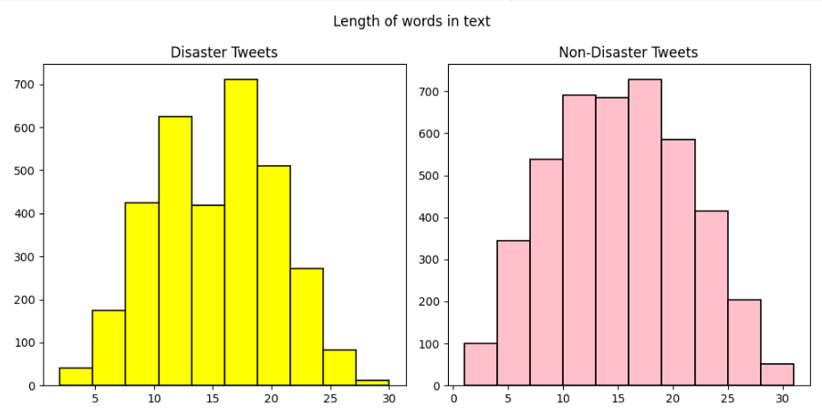

Analysing average word length in text.
fig,(ax1,ax2) = plt.subplots(1,2,figsize=(10,5))
char_len_dis = train[train['target']==1]['text'].str.split().apply(lambda x: [len(i) for i in x])
sns.histplot(char_len_dis.map(lambda x: np.mean(x)),ax=ax1,color='darkblue')
ax1.set_title('Disaster Tweets')
char_len_ndis = train[train['target']==0]['text'].str.split().apply(lambda x: [len(i) for i in x])
sns.histplot(char_len_ndis.map(lambda x: np.mean(x)),ax=ax2,color='green')
ax2.set_title('Non-Disaster Tweets')
plt.suptitle("Average Word Length in text")
plt.tight_layout()
plt.show()

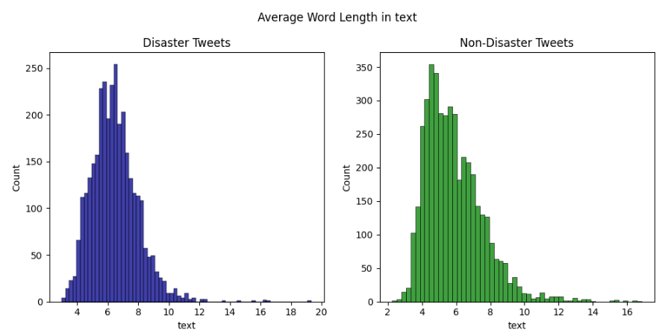
Let's explore the data further in depth:-
- Stop Words Analysis
- Punctuations Analysis
- Analysis of Missing words.

# Creating sample corpus for further analysis.
def create_corpus(target):
corpus = []
for x in train[train['target']==target]['text'].str.split():
for i in x:
corpus.append(i)
return corpus

# Analysing top stop words in text.
from collections import defaultdict

def analyze_stopwords(data,func,target):
values_list = []
for labels in range(0,len(target)):
dic = defaultdict(int)
corpus = func(target[labels])
for word in corpus:
dic[word]+=1
top = sorted(dic.items(),key = lambda x: x[1],reverse=True)[:10]
x_items,y_values = zip(*top)
values_list.append(x_items)
values_list.append(y_values)

fig,(ax1,ax2) = plt.subplots(1,2,figsize=(15,5))
ax1.barh(values_list[0],values_list[1],color="lightblue",edgecolor='black', linewidth=1.2)
ax1.set_title("Non-Disaster Tweets")

ax2.barh(values_list[2],values_list[3],color="lightgreen",edgecolor='black', linewidth=1.2)
ax2.set_title("Disaster Tweets")

plt.suptitle("Top Stop words in text")
plt.show()

analyze_stopwords(train,create_corpus,[0,1])

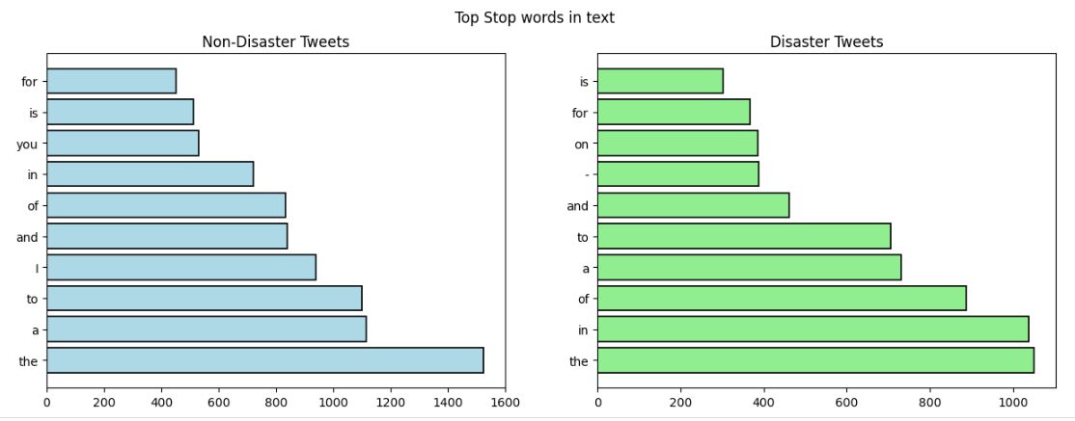

# Anaysing Punctuations
import string

def analyze_punctuation(data,func,target):
values_list = []
special = string.punctuation
for labels in range(0,len(target)):
dic = defaultdict(int)
corpus = func(target[labels])
for i in corpus:
if i in special:
dic[i]+=1
x_items,y_values = zip(*dic.items())
values_list.append(x_items)
values_list.append(y_values)

fig,(ax1,ax2) = plt.subplots(1,2,figsize=(15,5))
ax1.bar(values_list[0],values_list[1],color="lightblue",edgecolor='black', linewidth=1.2)
ax1.set_title("Non-Disaster Tweets")

ax2.bar(values_list[2],values_list[3],color="lightgreen",edgecolor='black', linewidth=1.2)
ax2.set_title("Disaster Tweets")

plt.suptitle("Punctuations in text")
plt.show()

analyze_punctuation(train,create_corpus,[0,1])

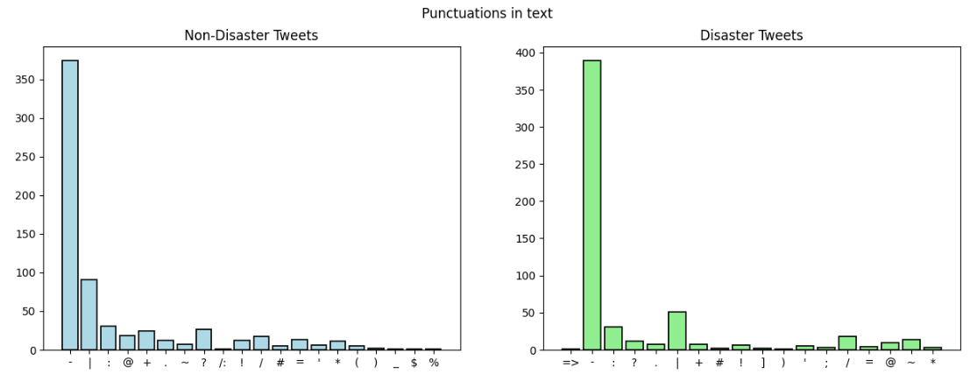

# Checking Null values
missing_train = train.isnull().sum()
missing_test = test.isnull().sum()
fig, (ax1,ax2) = plt.subplots(1,2,figsize=(15,5))
missing_train = missing_train[missing_train>0].sort_values()
ax1.pie(missing_train,autopct='%1.1f%%',startangle=30,explode=[0.9,0],labels=["keyword","location"],colors=['yellow','cyan'])
ax1.set_title("Null values present in Train Dataset")

missing_test = missing_test[missing_test>0].sort_values()
ax2.pie(missing_test,autopct='%1.1f%%',startangle=30,explode=[0.9,0],labels=["keyword","location"],colors=['yellow','#66ff00'])
ax2.set_title("Null values present in Test Dataset")
plt.suptitle("Distribution of Null Values in Dataset")
plt.tight_layout()
plt.show()

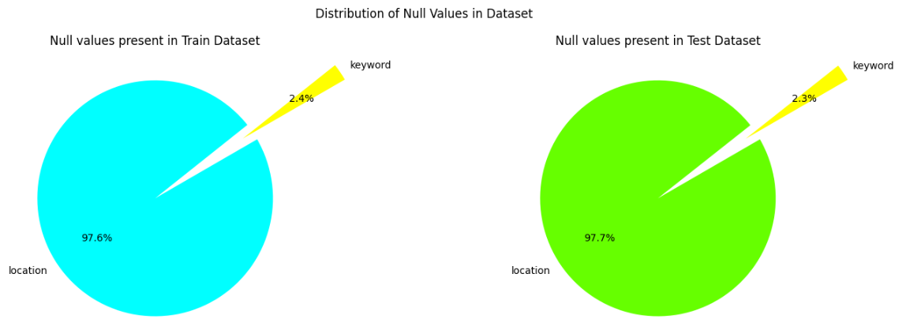

Let's analyze the keywords column:-

# Analysing Top 20 disastrous KeyWords in text .
plt.figure(figsize=(10,7))
train[train['target']==1]['keyword'].value_counts()[:20].plot(kind='barh', fontsize=12,title='Top 20 Disastrous Keywords in Text', color='#0096FF',edgecolor='black', linewidth=1.2)
plt.show()

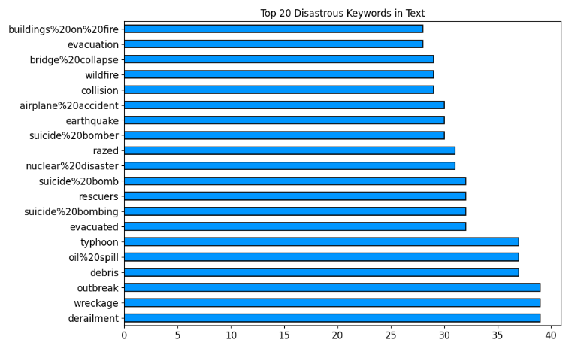
Let's analyze Locations column:-
# Analysing Top 20 disastrous Locations in text.
plt.figure(figsize=(10,7))
train[train["target"]==1]["location"].value_counts()[:20].plot(kind='barh',fontsize=12, title='Top 20 Disastrous Locations in Text', color='#66ff00',edgecolor='black', linewidth=1.2)
plt.show()

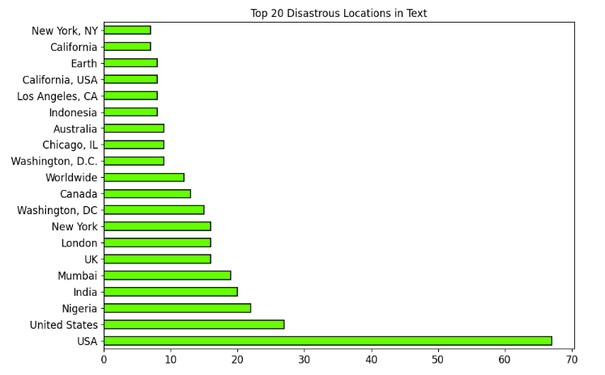
Let's Clean the Data. Following operations are carried out on text column for performing Data Cleaning
- Removal of URL's.
- Removal of HTMl tags.
- Removal of Emoji's.
- Filtering out miscellaneous text.
- Lowering the text.
- Performing Stemming (in case of bag of words(bow) and tf-idf) and lemmatization for (LSTM).
- Discarding words of length < 2.
Note: The Stemming process is performed for bow and tf-idf because there is no need of meaningful words while lemmatization is performed for LSTM because we do require meaningful words (discussed in subsequent sections).

# Seperating independent and dependent features
X = train.drop(columns=["target"],axis=1)
y = train["target"]

# Perfoming data cleaning

messages_train = X.copy()
messages_test = test.copy()

nltk.download('stopwords')

ps = PorterStemmer()
wl = WordNetLemmatizer()
def preprocess_data(data):
'''
Input: Data to be cleaned.
Output: Cleaned Data.

'''
review =re.sub(r'https?://\S+|www\.\S+|http?://\S+',' ',data) #removal of url
review =re.sub(r'<.*?>',' ',review) #removal of html tags
review = re.sub("["
u"\U0001F600-\U0001F64F" # removal of emoticons
u"\U0001F300-\U0001F5FF" # symbols & pictographs
u"\U0001F680-\U0001F6FF" # transport & map symbols
u"\U0001F1E0-\U0001F1FF" # flags (iOS)
u"\U00002702-\U000027B0"
u"\U000024C2-\U0001F251"
"]+",' ',review)
review = re.sub('[^a-zA-Z]',' ',review) # filtering out miscellaneous text.
review = review.lower() # Lowering all the words in text
review = review.split()
review = [ps.stem(words) for words in review if words not in stopwords.words('english')] #Stemming
review = [i for i in review if len(i)>2] # Removal of words with length<2
review = ' '.join(review)
return review

train["Cleaned_text"] = train["text"].apply(preprocess_data)
test["Cleaned_text"] = test["text"].apply(preprocess_data)

Let's take a look at Cleaned Data

train.head()

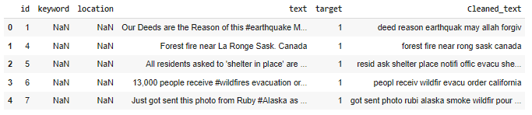
Let's analyze common words after cleaning of text using Word Cloud

# Analysing common words using WordCloud

wc = WordCloud(background_color='black')
wc.generate(' '.join(train['Cleaned_text']))
plt.imshow(wc, interpolation="bilinear")
plt.axis('off')
plt.show()

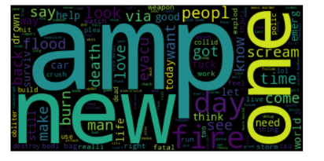
Let's further analyse top 50 words of disaster/non-disastrous in training data:-

# Analysing top 50 words in training data

disaster_tweet = train[train.target==1]["Cleaned_text"]
non_disaster_tweet = train[train.target==0]["Cleaned_text"]

color = ['Paired','Accent']
splitedData = [disaster_tweet,non_disaster_tweet]
title = ["Disaster Tweets", "Non-Disaster Tweets"]
for item in range(2):
plt.figure(figsize=(20,8))
plt.title(title[item],fontsize=12)
pd.Series(' '.join([i for i in splitedData[item]]).split()).value_counts().head(50).plot(kind='bar',fontsize=10,colormap=color[item],edgecolor='black', linewidth=1.2)
plt.show()

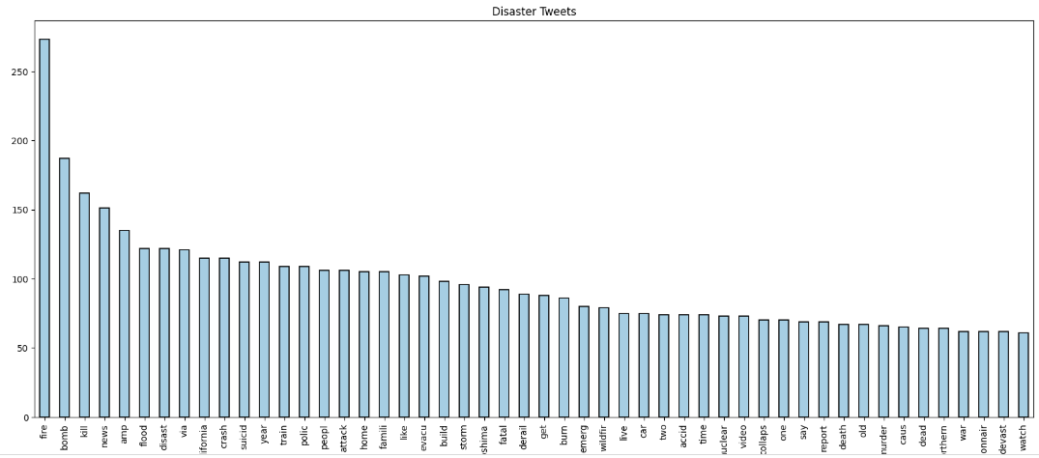

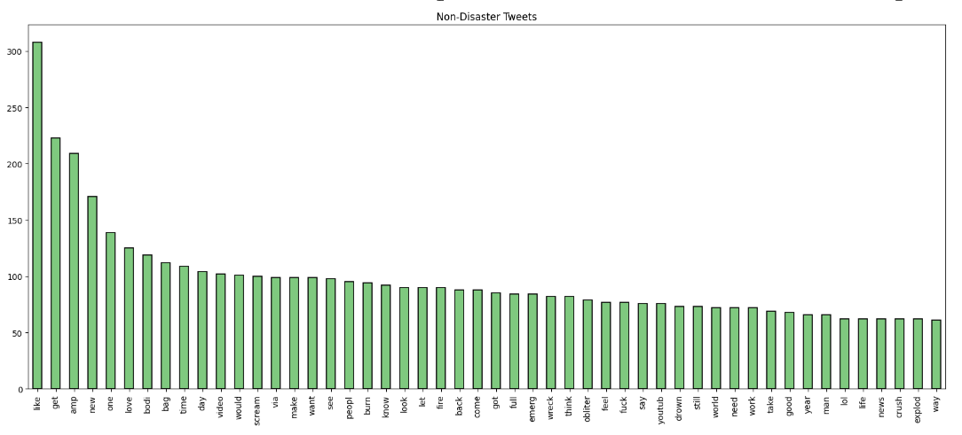

From above chart, it appears that our cleaned text still contains some unnecessary words (such as: like, amp, get, would etc.) that aren't relevant and can confuse our model, resulting in false prediction. Now, we will further remove some confusing words from text based on above charts.

common_words = ['via','like','build','get','would','one','two','feel','lol','fuck','take','way','may','first','latest'
'want','make','back','see','know','let','look','come','got','still','say','think','great','pleas','amp']

def text_cleaning(data):
return ' '.join(i for i in data.split() if i not in common_words)

train["Cleaned_text"] = train["Cleaned_text"].apply(text_cleaning)
test["Cleaned_text"] = test["Cleaned_text"].apply(text_cleaning)

Let's check one example whether there are any change occured or not

train.head(1) # Much more cleaner

Let's transform the data in numerical format that is suitable for prediction by models. We will use following techniques to transform the data.
- BOW
- TF-IDF.
- Word Embbedding using Glove Vectors.
Let's first start by analysing top N-grams using Bag Of Words.

# Creating function for analysing top n grams

def top_ngrams(data,n,grams):
'''
Input:- Data: Input Data
n : Number of top n-words
grams:Type of N-grams. 1-> Unigram 2-> Bigram 3->Trigram

Output: Word Frequency of top n words

'''
if grams == 1:
count_vec = CountVectorizer(ngram_range=(1,1)).fit(data)
bow = count_vec.transform(data)
add_words = bow.sum(axis=0)
word_freq = [(word, add_words[0, idx]) for word, idx in count_vec.vocabulary_.items()]
word_freq = sorted(word_freq, key = lambda x: x[1], reverse=True)
elif grams == 2:
count_vec = CountVectorizer(ngram_range=(2,2)).fit(data)
bow = count_vec.transform(data)
add_words = bow.sum(axis=0)
word_freq = [(word,add_words[0,idx]) for word,idx in count_vec.vocabulary_.items()]
word_freq = sorted(word_freq, key = lambda x: x[1], reverse=True)
elif grams == 3:
count_vec = CountVectorizer(ngram_range=(3,3)).fit(data)
bow = count_vec.transform(data)
add_words = bow.sum(axis=0)
word_freq = [(word,add_words[0,idx]) for word,idx in count_vec.vocabulary_.items()]
word_freq = sorted(word_freq, key = lambda x: x[1], reverse=True)

return word_freq[:n]

Plotting top 20 N-grams
common_words_uni = top_ngrams(train["Cleaned_text"],20,1)
common_words_bi = top_ngrams(train["Cleaned_text"],20,2)
common_words_tri = top_ngrams(train["Cleaned_text"],20,3)
common_words_uni_df = pd.DataFrame(common_words_uni,columns=['word','freq'])
common_words_bi_df = pd.DataFrame(common_words_bi,columns=['word','freq'])
common_words_tri_df = pd.DataFrame(common_words_tri,columns=['word','freq'])
fig,(ax1,ax2,ax3) = plt.subplots(3,1,figsize=(15,20))
ax1.bar(common_words_uni_df["word"],common_words_uni_df["freq"],color="#FFCCCB",edgecolor='black', linewidth=1.2)
ax1.set_title("Top 20 Unigrams in Text.")
ax1.set_xlabel("Words")
ax1.set_ylabel("Frequency")
ax1.set_xticklabels(rotation=90,labels=common_words_uni_df["word"],fontsize=10)

ax2.bar(common_words_bi_df["word"],common_words_bi_df["freq"],color="lightblue",edgecolor='black', linewidth=1.2)
ax2.set_title("Top 20 Bigrams in Text.")
ax2.set_xlabel("Words")
ax2.set_ylabel("Frequency")
ax2.set_xticklabels(rotation=90,labels=common_words_bi_df["word"],fontsize=10)

ax3.bar(common_words_tri_df["word"],common_words_tri_df["freq"] ,color="lightgreen",edgecolor='black', linewidth=1.2)
ax3.set_title("Top 20 Trigrams in Text.")
ax3.set_xlabel("Words")
ax3.set_ylabel("Frequency")
ax3.set_xticklabels(rotation=90,labels=common_words_tri_df["word"],fontsize=10)
plt.suptitle("Visualization of Top 20 Unigrams, Bigrams and Trigrams",fontsize="15")
plt.tight_layout(pad=1.85)
plt.show()

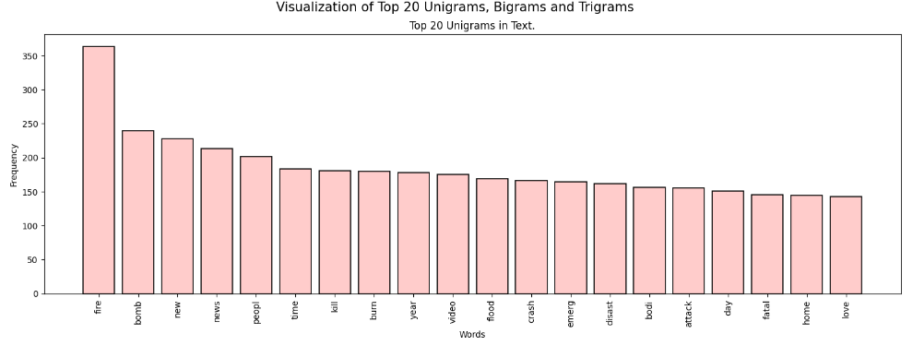
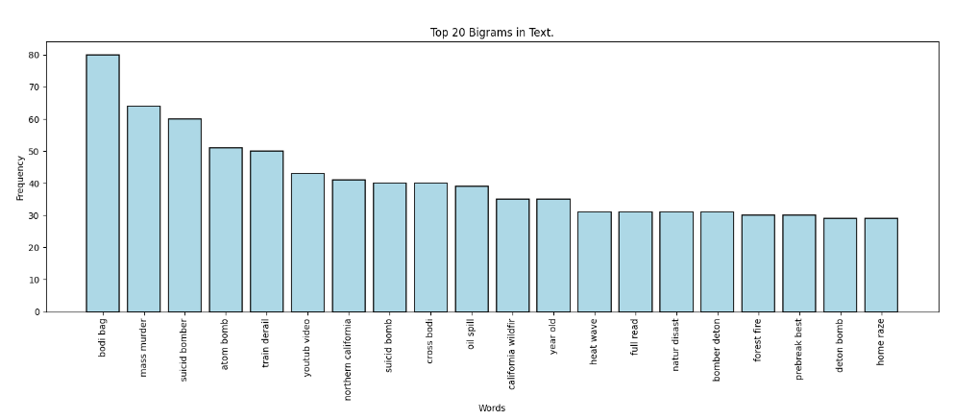

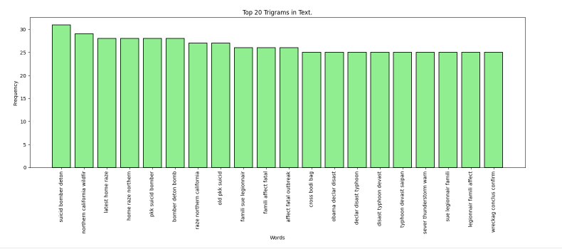

Let's perform data encoding using bow and tf-idf.
The function accepts cleaned training and testing data, boolean flags for selecting type of encoding as input and outputs cleaned text.

# Creating functions for using BOW,TF-IDF

def encoding(train_data,test_data,bow,tf_idf):
'''
Input : Data to be encoded and choice of encoding.
Output : Desired Encoding.

'''
if bow==True:
cv = CountVectorizer(ngram_range=(1, 1))
cv_df_train = cv.fit_transform(train_data).toarray()
train_df = pd.DataFrame(cv_df_train,columns=cv.get_feature_names_out())
cv_df_test = cv.transform(test_data).toarray()
test_df = pd.DataFrame(cv_df_test,columns=cv.get_feature_names_out())

elif tf_idf==True:

tfidf = TfidfVectorizer(
ngram_range=(1, 1), use_idf=1,smooth_idf=1,sublinear_tf=1)
tf_df_train = tfidf.fit_transform(train_data).toarray()
train_df = pd.DataFrame(tf_df_train,columns=tfidf.get_feature_names_out())
tf_df_test = tfidf.transform(test_data).toarray()
test_df = pd.DataFrame(tf_df_test,columns=tfidf.get_feature_names_out())

return train_df,test_df

x_final,x_test_final = encoding(train["Cleaned_text"],test["Cleaned_text"],bow=True,tf_idf=False)
y_final = np.array(y) # Converting y to array

# Checking dimensions of training and testing data
x_final.shape,y_final.shape,x_test_final.shape

Using Word Embedding using Glove Vectors for Encoding:-

#Converting to list
text = train["Cleaned_text"].tolist()
text_test = test["Cleaned_text"].tolist()
text[:3] # Analysing first 3 sentence in train data.

Let's initialize a Tokenizer to read all the words in the text.
from tensorflow.keras.preprocessing.text import Tokenizer
token = Tokenizer()
token.fit_on_texts(text)

# Finding the vocab size
vocab_size = len(token.word_index)+1
print("The vocabulary size is : {}".format(vocab_size))

# Encoding tokens in words to numerical formats
encoded_text = token.texts_to_sequences(text)
encoded_text_test = token.texts_to_sequences(text_test)
encoded_text[:2]

#Considering 120 words
max_length = 120 # Considering top 120 tokens.
X = pad_sequences(encoded_text,maxlen=max_length,padding='post') # This is done to make the sequence of same length.
X_test = pad_sequences(encoded_text_test,maxlen=max_length,padding='post')
X

Let's create some Models !!!

# Dividing the data into training, validation and testing
from sklearn.model_selection import train_test_split
# for bow and tf-idf
#x_train, x_test, y_train, y_test = train_test_split(x_final, y_final, test_size=0.1, random_state=42, stratify = y_final)
#X_train, x_valid, Y_train, y_valid = train_test_split(x_train, y_train, test_size=0.1, random_state=42, stratify = y_train)
#x_test_final = x_test_final

# for Word Embeddings
x_train, x_test, y_train, y_test = train_test_split(X, y, test_size=0.1, random_state=42, stratify = y)
X_train, x_valid, Y_train, y_valid = train_test_split(x_train, y_train, test_size=0.1, random_state=42, stratify = y_train)
#x_test_final = x_test_final

1.Long Short Tem Memory (LSTM)
from keras.optimizers import Adam,SGD
from tensorflow.keras import regularizers

embedding_feature_vector = 200 # Since we used glove vector embedding of dim 200.
model = Sequential()
model.add(Embedding(vocab_size,embedding_feature_vector,input_length=max_length, trainable = False))
model.add(Dropout(0.35))
model.add(LSTM(200))
model.add(Dropout(0.35))
model.add(Dense(32,activation='relu'))
model.add(Dense(1,activation='sigmoid'))
model.compile(loss='binary_crossentropy',optimizer=Adam(lr=1e-4),metrics=['accuracy'])
print(model.summary())

from tensorflow.keras.callbacks import *
n_epoch = 30

early_stop = EarlyStopping(monitor='val_loss', patience=5, verbose=1,
mode='min', restore_best_weights=True)

reduce_lr = ReduceLROnPlateau(monitor='val_loss', factor=0.1, patience=5,
verbose=1, mode='min')

# Training the model
history = model.fit(X_train,Y_train,validation_data=(x_valid,y_valid),callbacks=[reduce_lr,early_stop],epochs=n_epoch,batch_size= 64)

predictions = (model.predict(x_test) > 0.5).astype("int32")
cr = classification_report(y_test,predictions)
print(cr)
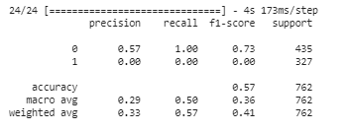
- Logistic Regression

model_1 = LogisticRegression(C=1.0)
model_1.fit(X_train,Y_train)
pred_1 = model_1.predict(x_test)
cr1 = classification_report(y_test,pred_1)
print(cr1)
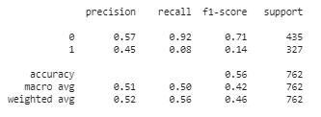
- Naive Bayes

model_2 = MultinomialNB(alpha=0.7)
model_2.fit(X_train,Y_train)
pred_2 = model_2.predict(x_test)
cr2 = classification_report(y_test,pred_2)
print(cr2)
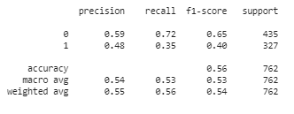
Now, Let's Compare the performance of various ML/DL Models
acc_1 = 0.78084
acc_2 = 0.78740
acc_3 = 0.82021

results = pd.DataFrame([["Logistic Regression",acc_1],["Naive Bayes",acc_2],
["LSTM",acc_3]],columns = ["Models","Accuracy Score"]).sort_values(by='Accuracy Score',ascending=False)
results.style.background_gradient(cmap='Blues')
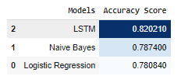
Conclusion From the above table, it appears that LSTM model performs the best by achieving an overall accuracy of about 82.02% while Passive Aggresive Model performs less accurately by outputing an accuracy score of about 78.08% .
Since, the LSTM Model shows robust performance, therefore it is selected as the final prediction model.

